Super Simple Homemade Date Paste

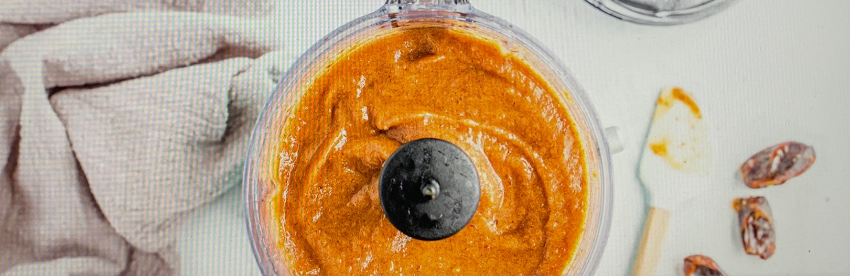

YIELDS. PREP TIME COOK TIME TOTAL TIME
4 servings 10 mins 0 min 2 hrs 10 min

Adding nutrient-packed natural sweetness to desserts can come from fruit pastes, which are made by soaking dried fruit in water, sometimes with spices or citrus, and then pureeing the thick mixture until smooth. Commonly made from dried dates, figs, apricots, or mangoes, fruit pastes are core ingredients for a plant-based diet.

Ingredients -
1 cup dates pitted
3/4 cup water

Directions
- Soak dates in water, so that they are completely covered, for 2 hours or more.
- Drain.
- Add the dates and 3/4 cup of water to a food processor or blender and blend until smooth.
- Store in an airtight container in the refrigerator for up to one week or freeze for three months.
- Use as needed to sweeten desserts, baked goods, smoothies, and more

